Insurance decisions with “Probable Small Probabilities”: The role of Framing and Incentives under Risk and Ambiguity

Rocco Caferra Andrea Morone John Hey

Abstract
This paper considers a situation where a decision-maker (DM) is faced with the decision whether and how much to insure against a bad event which may occur sometime during a T-period horizon. If it occurs at any time during this period, the DM loses everything, unless he/she is insured. Now, whether the DM is given the information that the event may occur in any one period with probability p, or given the information that it may occur sometime during the T periods with probability P, then if P = 1−(1−p)^{T}, the insurance decision should be the same; the only difference is the framing of the information. However, numerous studies have shown that framing may affect decision-making. We investigate experimentally whether this is the case in this particular context. We find that framing does matter. We also investigate whether incentivisation affects the decision, by running two different treatments, one with incentives and one without. It is clear from our results that incentives matter, though in an unexpected way.
Keywords: Insurance; Choice under uncertainty; Ambiguity; Risk; Ambiguity Box; Large Probabilities; Equivalent Small Probabilities; Incentivisation; Framing.
JEL Classification: G22; C91; D81

rocco.caferra@gmail.com
andrea.morone@uniba.it
john.hey@york.ac.uk

- Introduction
Even though an individual event may have a very small probability of happening, if a process is repeated many times, the probability of it happening sometime during the repetitions may be large. By “Probable Small Probabilities,” we refer to this context, where small probabilities of an event occurring in each period lead to a significant overall probability. Consider, for example, an event with a low probability, p, of occurring in any given year, and ask: “What is the probability of it occurring at least once during a t-year period?” The result is surprisingly high. For example, if p is 0.01 and T is 50, the probability (P) of it happening sometime in the 50 periods is given by 1−(1−p)^{T}=0.395.
Asking individuals how much they are willing to invest to insure against an adverse event with a 39.5% probability over the next 50 years should not lead to different behaviour compared to insuring against an event with a 1% probability each year for 50 years, since only the framing of the information has changed.
Theoretically, objective information should not affect the insurance decisions of a rational decision-maker. However, empirical evidence shows that decision-making in this domain is influenced by psychological and contextual factors, such as the perception of probability, the time horizon, and the framing of decisions (Laury et al., 2009). This study explores these factors to better understand framing effects in insurance decisions. Recent developments in the analysis of the insurance market have highlighted the need to study behavioural aspects in insurance demand, such as contract framing, clarity of risk and ambiguity, and loss aversion in relation to the size of losses (Corcos et al., 2020; Le Roux, 2020). Following this line of research, this work examines three key aspects of risk communication: framing, ambiguity, and the salience of economic consequences.
First, we aim to explore how the framing of insurance decisions and the probability of adverse events influences subjects' insurance behaviour. In our experiment, we compare insurance decisions for the overall probability of the event (P) with those for the intra-period probability (p) for each sub-period within the whole timeframe. Individuals often have difficulty evaluating low-probability, high-loss events (Kahneman and Tversky, 2013; Tversky et al., 2000), which can result in underestimating the likelihood of such events and, consequently, a lower demand for insurance (Kunreuther and Pauly, 2004). This tendency can be explained by probability weighting (Barberis, 2013), where people overweigh small probabilities and underestimate the risks of rare disasters. As a result, individuals may either underinsure against catastrophic events or over insure against more frequent, less severe risks. The way the same risk is communicated can lead to significant and different consequences in determining individuals' risk preferences. As highlighted by Henrich et al., (2015), risk perceptions are influenced not only by the objective facts about the risk itself but also by how those facts are presented. This phenomenon, known as the "framing effect," can cause people to react differently to the same underlying risk depending on the language and context used to describe it. An additional explanation for this type of over (or under) weighting may stem from narrow bracketing. That is, on the one hand, it is true that people often consider small probability events, like natural disasters, too rare to warrant concern or attention (Kunreuther 1996; Robinson and Botzen, 2018) following prospect theories (Hertwig et al, 2004). On the other hand, individuals might exhibit myopia or narrow bracketing, focusing on short-term risks instead of long-term exposure (Kahneman and Lovallo 1993), then reporting the cumulative risk over time, counteracting narrow-bracketing with broad-bracketing over the whole cumulative probability, could lead people to opt for more protective actions (Chaudhry et al., 2020). That is, with narrow-bracketing, people evaluate the limited timeframe, not considering the cumulative probability P of the event, but only the small probability p at each time t. On the other hand, with broad-bracketing, they choose by observing the complete picture, so when presented with the small probability p over T periods, they are still able to identify the cumulative P and make their choice based on that.
For example, consider the following two statements (Henrich et al., 2015): "There is a 10% chance in 50 years that an earthquake will kill 1,600 people" and "An earthquake that occurs once every 500 years on average kills 1,600 people". Although both describe the same statistical risk, the way the risk is framed leads to different emotional reactions and judgments, since the first statement, which emphasizes the probability of the event over time, might make the risk seem more immediate or likely, while the second statement, which frames the earthquake as a rare event, could make the risk seem less urgent and more distant. The frequency of such events may be higher than initially perceived. For example, there is a 34% chance of an eruption at Vesuvius in Italy within the next 50 years (Selva et al., 2022), even though the probability of an eruption in a single year is only 0.086%. This suggests that events with seemingly low probabilities may not be as rare as they appear. Risk communication reflects various aspects of real-life daily risk choices, spanning areas such as healthcare, economics, and financial risks.
Let us imagine a risky investment where there is a 2.50% probability of losing the amount invested in each of the next 20 years. This leads to an overall probability of 40% that at least once this event might happen. But are individuals truly so short-sighted in their decisions that they underestimate the underlying risk simply based on how it is presented to them? At first glance, the solution might seem simple: it could be better to always focus on the overall probability, communicating the cumulative probability of the phenomenon rather than the smaller, intra-period probability that may occur within each time period. However, as we will demonstrate in our experiment, the solution is not so straightforward. First, one must consider how large the overall probability is. Moreover, it is not necessarily true that individuals will ignore small probabilities, as the frequency — that is, the timeframe considered for the framing — could counterbalance the effect of the small probability. Anyway, we could say that the first source of incentive and salience in the experiment is the perception of risk, and this can depend on how it is communicated.
The second aspect is related to the clarity of the risk communication. Policymakers have a responsibility to present risks as clearly and transparently as possible, especially in situations where the data is uncertain or ambiguous. Clear communication enables individuals to better understand the risks they face and, as a result, adjust their risk mitigation behaviours accordingly (Viscusi et al., 1991; Viscusi, 1997). For example, during the COVID-19 pandemic, clearer risk communication led people to search for more information and purchase more insurance, while vague or conflicting information can lead to confusion, causing individuals to either underestimate or overestimate the risks, which can result in inadequate risk management actions (Feng et al., 2023). This ambiguity can undermine the effectiveness of risk mitigation strategies, as individuals may not make informed decisions, and then they can demonstrate a different behaviour compared to their risk mitigation activity under clear risk. Our study contributes to this debate by exploring decision-making under both risky and ambiguous conditions. While risk involves known probabilities, ambiguity introduces unknown probabilities, reflecting real-world decision-making contexts where probabilities are inferred (Ghirardato et al., 2004) or guessed. To investigate this, we use the Ambiguity Box, a tool that dynamically presents uncertainty and enforces participants to infer probabilities through visual animations (Morone and Caferra, 2024). The salience and the clearness of risk communication can be, in itself, another source of incentive to foster the risk management activities of subjects. In this paper, we consider the joint effect of framing and the clarity of risk communication. Connecting this to narrow-bracketing, in this case, given the same small p over T, it is possible to understand whether the way individuals insure themselves is related not only to the perceived magnitude of the probability but also to the difficulty in identifying it. Then, narrow-bracketing can be amplified, as complicated calculations may discourage individuals from identifying the problem, or ambiguity can lead individuals to increase their cognitive effort in identifying the underlying dynamics.
Third, we consider whether the magnitude of economic consequences can make small probabilities more salient, influencing more rational and reflective choices. To explore this, we examine incentivised treatments (real economic consequences) versus hypothetical ones (no actual losses). Incentivisation has been central to experimental economics (Plott, 1986; Smith, 1982, 1991), though its impact is debated (Matousek et al., 2022). The role of economic incentives in experiments has been widely debated, as outlined in a recent review by Voslinsky and Azar (2021). On one hand, performance-based monetary incentives are considered essential for replicating real-life aspects of the benefits and costs associated with decisions (Cox and Sadiraj, 2019), leading to more accurate responses and, consequently, more meaningful results (Burke et al., 1996; Clot et al., 2018). Moreover, incentivizing experiments ensures that subjects behave naturally (Madsten and Stenheim, 2015). On the other hand, while asking hypothetical questions to elicit preferences might lead subjects to misrepresent their true intentions, there is a concern regarding the incentive to lie (Voslinsky and Azar, 2021). Then, evidence suggests that incentivised experiments may not always differ from hypothetical experiments in behavioural dynamics but can influence impulsivity and decision-making systems (Caferra et al., 2023). This has led various economists over time to compare incentivized scenarios with non-incentivized ones (Thaler, 1994).
In this context, assuming that subjects may tend to ignore small probabilities, we can examine whether this effect exists and is amplified when there are no real economic consequences. The magnitude of consequences can also alter probability weighting processes, leading to different outcomes (Etchart-Vincent, 2004). Following Slovic et al. (2013), the presence of incentives leads to treating the risky context in a more analytical and precise way. Consequently, in this study, we replicate the experiment both with and without economic incentives, comparing the results. It is interesting to explore whether risk preferences and thus the associated insurance behavior, change depending on the existence of economic consequences. Following the existing literature, we might expect changes in both risk preferences and probability weighting, as well as a reduction in the accuracy of responses. Thus, we aim to examine the role of risk communication and how it influences participants' choices, considering both the salience of the communication—through framing and the clarity of the risk presented—and the salience of economic consequences, by comparing real versus hypothetical outcomes. At this stage, we can anticipate that, in terms of risk preferences, we do not observe significant changes compared to the incentivized case, where there is a shift from risk aversion for low probabilities to risk neutrality for higher probabilities. As the risk increases, individuals tend to maintain a high level of risk aversion, with a wealth effect encouraging them to insure less in order to maintain sufficient net disposable income in the event of gains. This dynamic is almost robust. Probabilities are weighted differently only in some cases, but overall, we can say that people do not tend to completely ignore low probabilities even without incentives. The most evident result lies in terms of accuracy, where, as noted in the inferential analysis, the variance of the coefficients is higher, the statistical significance of the relationships is much lower, and the response time is much faster, suggesting less reflective answers compared to the incentivized case. Consequently, the differences between the two cases are not trivial and are not always obvious. However, some of these differences clearly support incentivized experiments, while also showing that hypothetical settings should not be perceived as entirely incorrect, as certain relationships persist.
In this study, we recruited a total of 160 subjects, equally divided between incentivized and non-incentivized treatments. Within these treatments, by isolating the individual effects, we were able to identify changes in their reservation prices for insurance against an adverse event that could cause them to lose all potential income. First, we note that subjects do not ignore probabilities, regardless of the framing in which they are presented. However, the results indicate that presenting cumulative probabilities reduces narrow-bracketing and the underestimation of low probabilities, in line with Chaudry et al., (2020), When the underlying cumulative probability is not high, though, a framing where probabilities are small and intraperiodic leads to an increased perception of probability and a higher willingness to insure. It is interesting to note that there is no universally applicable strategy for all cases, but it is important to differentiate based on the size of the underlying probability, since narrow-bracketing can sometimes be useful. In ambiguous decision problems, we observe greater cognitive stress in identifying probabilities, which is reflected in the difficulty of determining the underlying risk, even when cumulative probability is reported. This makes ambiguity a distinct issue from narrow-bracketing and underweighting of probabilities, where making risky communication clearer always works better for individual insurance decisions.
By comparing incentivized and non-incentivized sessions, we generally find that the dynamics are similar. This is interesting because our design could also be applied to survey-based studies. However, we observe a greater erratic component and less reflective choices, making the results statistically insignificant. From this, we conclude that incentivized studies do not alter the overall dynamics, but they work better in defining individuals' insurance behaviors, shedding lights on the potential benefit of conducing incentivized experiment in this field. The remainder of the paper is organized as follows: Section 2 outlines the experimental design, Section 3 presents the results, and Section 4 concludes.

- Theoretical framework and experimental design
As anticipated, the framing of the risky communication is based on the following formula. The probability of an adverse event occurring over a time horizon of T years with a cumulative probability P can be reframed as an equivalent annual probability p, derived from the equation:
(1−p)^{T}=1−P
That is, the probability 1-P that an event will not happen in the whole time frame is equal to the probability 1-p that it is not happening in each of the T subperiods. This reframing highlights how cumulative probabilities over extended time horizons translate into seemingly smaller per-period probabilities. For example, an adverse event with P=40% over 10 years corresponds to an annual probability of p=5%. Such transformations may affect an individual's willingness to pay (WTP) for insurance coverage, as the framing shifts perceptions between high cumulative risks and smaller per-period probabilities.
To examine these effects, the study incorporates four main parts, distinguishing between decision-making under ambiguity and risk:
- High Probability Decisions Under Risk: Subjects are presented with four decision problems involving risky high probabilities, P, that the adverse event can occur overall.
- Low Probability Decisions Under Risk: Subjects address 12 decision problems derived from the equivalent risky small annual probabilities p.
- High Probability Decisions Under Ambiguity: Subjects are presented with four decision problems involving ambiguous high probabilities, P, overall (Replication of Section 1 under ambiguity conditions).
- Low Probability Decisions Under Ambiguity: Subjects address 12 decision problems derived from the equivalent ambiguous small annual probabilities p. (Replication of Section 2 under ambiguity conditions),

The experiment manipulates two core variables:
- Probabilities (P): Four high cumulative probabilities (P=20%, 40%, 60%, 80%).
- Time Horizons (T): Three timeframes representing short (T=10), medium (T=20), and long (T=50) terms. In the case where the large probabilities P are reported, no reference is made to the time frame or the presence of sub-periods in order to avoid influencing their perceptions or introducing any bias regarding the immediacy or distance of the event. Therefore, the subjects are aware of the overall probability with which the phenomenon can occur. In this case, we are talking about an event with overall probability without ever mentioning reference time intervals, so as not to give the subjects any perception or bias about the immediacy or distance of the event.
By combining these parameters, 12 unique cases with small probabilities are generated, allowing the calculation of the corresponding annual probabilities, p, for each scenario. Considering also the case with Large probabilities where the time period is not specified (T=NS), we have 16 different cases. Table 1 reports the main relationships between p and P over T (p rounded up to the 2 decimal points for ease of viewing).
Each subject answers questions both under ambiguity and risk scenarios. As noted, the ambiguity scenarios are presented first, followed by those under risk. The order is designed so that ambiguity scenarios, where probabilities must be estimated, come before those where probabilities are explicitly provided, to avoid any potential anchoring effects when inferring the objective probabilities.
The decision to use a within-subject design is based on at least three reasons: first, we do not have concerns about potential learning effects that would have obliged us to consider between designs, since if subjects are skilled at inferring probabilities in ambiguous situations, this will not distort their behavior in risk scenarios, as the task does not rely on their ability to estimate probabilities, since these are provided. Furthermore, there is no opportunity for hedging, as only one randomly chosen option is selected for payment, Finally, this design allows us to observe how choices shift when transitioning from risk to ambiguity, while holding individual characteristics constant. This ensures that any observed differences are not due to varying abilities in risk management or cognitive skills in probability handling estimation, thus minimizing the impact of unobserved individual differences in behavior.
Another point can be related to the length of T. Having framed the situation where small probabilities are expressed as p over T could raise concerns about the length of T, thus introducing a problem of intertemporal choices and time preferences. However, in our framing, this is not an issue, because timing is more likely to be related to frequencies. In fact, the event occurs with probability p in each of the intraperiods T, making exactly T independent draws with probability p. This makes the event equiprobable in each period and does not alter the immediacy or distance of the probability. Instead of a "time" effect, we have a "frequency" effect, as for a given P, p and T are inversely correlated (for lower probabilities, more T draws are required for the same P). This is a characteristic intrinsic in the design and not related to the perception of time.

Table 1 Relationships between p and P over T (p rounded up to the 2 decimal points for ease of viewing).
Overall High Probability (P;T=NS) | Equivalent Low probability (p)
Overall High Probability (P;T=NS) | T=10 | T=20 | T=50
20% | 2.20% | 1.10% | 0.40%
40% | 5.00% | 2.50% | 1.00%
60% | 8.80% | 4.50% | 1.80%
80% | 14.90% | 7.70% | 3.20%

Subjects’ WTP for insurance was elicited using the Becker-DeGroot-Marschak (BDM) mechanism in two scenarios:
- Insurance covering total income loss over T years with cumulative probability P.
- Insurance covering total income loss annually over T years with probability p each year.

Let us provide more information about the visual representation of decision problems. Each subject, for each of the 32 decision problems faced (16 risky and 16 ambiguous cases, following table 1), is endowed with 10 euros. At the end of the experiment, one among the decision problems is randomly selected and the adverse event is played out.
If subjects are insured, independently from the event realized in the specific decision problem, they earn 10 euros minus the price paid for the insurance.
Conversely, if they are not insured, if the adverse event is not realized, they earned 10 euros, otherwise they lose their whole endowment. This is making extremely salient the size of economic losses.
Table 2 further summarizes the main aspects, while the instructions will be reported in the supplementary material.

Table 2. Summary of the experiment.
 |  | Part 1 | Part 2 | Part 3 | Part 4
First Screen | Description of the Adverse Event | ❌ No subperiods ✅ Adverse event extracted from the Ambiguity Box ❌ The overall Probability P is not displayed | ✅ Subperiods ✅ Adverse event extracted from the Ambiguity Box  ❌ The intra-periodic probability p is not displayed | ❌ No subperiods ❌ No Ambiguity Box ✅ The overall Probability P is displayed | ✅ Subperiods ❌ No Ambiguity Box ✅ The intra-periodic probability p is displayed
First Screen | Declaration of the Reservation price | Declared between 0 and 10 Euros | Declared between 0 and 10 Euros | Declared between 0 and 10 Euros | Declared between 0 and 10 Euros
Second Screen | Drawing of the insurance price | Drawn between 0 and 10 Euros | Drawn between 0 and 10 Euros | Drawn between 0 and 10 Euros | Drawn between 0 and 10 Euros

As can be observed, for each decision, two screens are displayed, In the first and third part (large probabilities under ambiguity and under risk), subjects faced four questions respectively, following the first column of table 1 (P=20% ;P=40%; P=60%; P=80%). In the Part 2 and 4, subjects took their insurance decisions in 12 scenarios respectively, following the second, third and fourth columns of table 4 (and then the combination of Large P and T into the formula P=1-(1-p)^{T}).
In the first screen, independently from the part of the experiment, the description of the condition under which the adverse event is realized is displayed. After the description, subjects have to declare their reservation price for buying the insurance. In table 3, the template of the framing of the adverse event for each of the 4 parts is reported.

Table 3. Framing across parts. Questions are randomized at subjects’ level within each part.

 | First Screen (upper part). Framing of the Adverse event (format type) | Notes
Part I | "Your endowment is 10 ECU. The probability of losing your entire endowment is given by the proportion of red squares in the animated box. The red and blue squares are continuously moving within the box, but their number remains constant. At the end of the experiment, a square will be drawn from the box. You can insure yourself against the possibility of losing your entire endowment if the adverse event occurs." (See an example of the Ambiguity box in figure 1) | This is the case where no time frame is referenced in the text. The subjects must estimate the probability by observing the Box (ambiguity condition).
Part II | "Your endowment is 10 ECU. The problem takes place over [T] periods. In each of the [T] periods, there is a probability of losing everything. The probability of losing your entire endowment in the game is given by the proportion of red squares in the animated box. The red and blue squares continuously move inside the box, but their number remains constant. At the end of the experiment, a tile will be extracted from the box. This operation will be repeated for each period. If in at least one of these periods the adverse event occurs and you are not insured, you will lose your endowment. You can insure yourself against the possibility of losing your entire endowment if the adverse event occurs. How much are you willing to pay to buy the insurance?" | In this case, the occurrence of the event is observed over T periods, we have all the p and T presented in Table 1, (ambiguity condition).
Part III | "Your endowment is 10 ECU. The probability of losing your entire endowment is [P%]. You can insure yourself against this eventuality. How much are you willing to pay to buy the insurance?" | An analogous procedure to part I, but in this case, the objective probability of the event is given (Risky condition).
Part IV | "Your endowment is 10 ECU. The game takes place over [T] periods. In each of the [T] periods, there is a [p%] chance of losing everything. If in at least one of these periods the adverse event occurs and you are not insured, you will lose your endowment. You can insure yourself against this eventuality. How much are you willing to pay to buy the insurance?" | An analogous case to part II with the declaration of the objective probability (Risky conditions).

Figure 1 shows an example of the Ambiguity Box (the animated version can be found in the additional material).

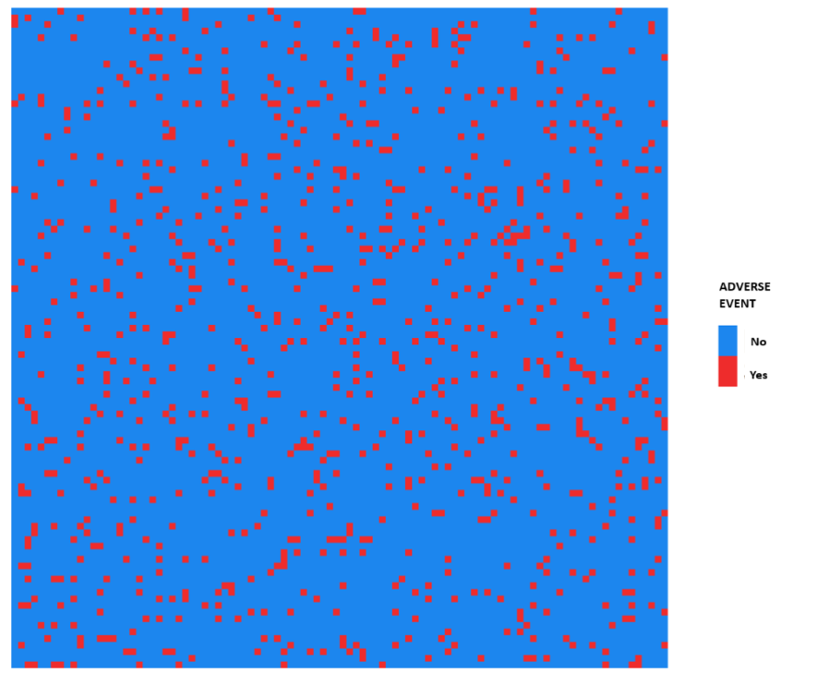
Figure 1. Ambiguity box with Underlying P=40%. The value of the probability is never provided to subjects.

As can be observed, subjects can make inferences about the true value of the probability by trying to estimate the proportion of red squares. However, since the squares are continuously moving, it is difficult to clearly identify the true probability. The event can occur within the decision problem with a certain probability described in the specific problem. Regarding the occurrence of the event, subjects are provided with a box containing moving squares. The number of squares of each color varies across decision problems but remains constant within a given problem. If such a problem is selected for payment, the procedure will be as follows to determine if the adverse event occurs, in order to determine the final endowment: within the box, a single random extraction is made to determine whether the adverse event occurs or not if a scenario with cumulative large P is selected, while one independent drawn for each subperiod T is made for the scenarios under low probabilities. This is made clear to participants from the beginning of the experiment.
In cases of objective risk, to avoid any form of error and heterogeneity in the risk estimate, we decided not to offer a static version of the box, where subjects would still have to count the squares of each color, Instead, we clearly stated the probability in the text to prevent any form of ambiguity.
Considering the second part of the First Screen, the layout is the same for all four parts. That is, subjects are asked to declare the reservation price for the insurance.
"How much are you willing to pay to buy the insurance? Please state the price you are willing to pay. You cannot pay more than your initial endowment of 10 ECU. Afterwards, a random value will be drawn between 0 and 10 ECU. Remember that if the price you declared is greater than or equal to the drawn price, you will purchase the insurance at the drawn price, If the price you declared is lower than the drawn price, you will not purchase the insurance and thus will not be insured."
Therefore, the purchase of insurance works as follows:
- Subjects are asked to report their Reservation Price (WTP). This price must be between 0 and their initial endowment.
- Then, they are informed of the insurance price, which will be randomly drawn between 0 and their endowment.
At this point, if the WTP is greater than or equal to the insurance price, subjects purchase the insurance and pay the insurance price drawn. That is, we apply the standard Becker-DeGroot-Marschak (BDM) mechanism to incentivize subjects to reveal their true preferences.
It is important to note that the questions are randomized within each part, but the order of the parts was deliberately kept constant to present the ambiguity conditions first and then the risky conditions, in order to avoid anchoring to the objective probabilities (given in the risky conditions) by the subjects.
In this way, it is possible to analyze, given the same underlying probability, whether the framing and clarity of the communicated risk, differentiating between risk and ambiguity, lead to different results.
- Results
The experiment was conducted at the University of Bari, with 80 participants recruited for the incentivised treatments and 80 for the non-incentivised treatments, resulting in a perfectly balanced sample. A priori power analysis for the dependent mean conducted with G-power supports the sample size used, given that with an alpha = 0.05, 1-beta = 0.95, and a medium effect size, the required sample size is 54, which is clearly below the number achieved through recruitment. We adopted a mixed design, as within each session, each participant responded to 32 decision problems (within-subject design); different participants took part in the incentivised and non-incentivised sessions (between-subject design). Under incentives, subjects earned on average 6.10 euros, the average time was around 30 minutes.
In what follows, we first present the results regarding the case with real economic consequences, followed by an analysis of the case in which the economic consequences are hypothetical. This allows us to examine not only the salience of the magnitude of the probability but also the magnitude of the economic effects on participants' choices.
3.1. Incentivised Treatments
The baseline results are reported in Tables 4. Specifically, Table 4a shows the average willingness-to-pay under conditions of risk, while Table 4b presents the results under conditions of ambiguity. In both tables, we consider also the prediction for a Risk-Neutral Ambiguity-Neutral (RN-AN) subjects. That is, we compute the expected WTP level for this type of subject. Following a standard microeconomic theory, A RN-AN is expected to invest in insurance the proportion of the endowment (E) based on the size of P, that is, P*E. This comparison allows us to analyze the complex relationship between Demand Insurance, Risk Aversion, and Income Effect (Cleeton and Zellner, 1993). We study the risk-aversion by analyzing the willingness-to-pay across different framings without the need to estimate individual risk aversion, as it emerges implicitly from the comparison between the risk-neutral theoretical prediction and the observed value reported by subjects.

 | - Risk Incentivised |  |  | dd
 |  | Time Horizon |  |  |  |  | Risk-Neutral
Probability | T=NS | T=10 | T=20 |  | T=50 |  | Prediction
20% | 4.08 | 4.73 | 4.43 |  | 4.08 |  | 2
40% | 5.61 | 5.27 | 5.32 |  | 4.86 |  | 4
60% | 6.32 | 6.06 | 5.9 |  | 5.6 |  | 6
80% | 7.7 | 6.16 | 6.05 |  | 5.79 |  | 8

 | b) Ambiguity Incentivised
 |  | Time Horizon |  |  | RN-AN
Probability | T=NS | T=10 | T=20 | T=50 | Prediction
20% | 4.19 | 5.04 | 5.06 | 4.71 | 2
40% | 5.17 | 5.19 | 4.95 | 4.97 | 4
60% | 6 | 5.77 | 5.82 | 5.38 | 6
80% | 5.9 | 6.19 | 6.18 | 5.69 | 8

Table 4. Average WTP across scenarios.

A graphical representation is reported in Figures 2 and 3. We analyse data moving row by row and column by column of table 1. Specifically, moving by column, given a cumulative probability P, we observe how the WTP changes when the same event with that underlying probability is described using different time intervals (present in the different columns of the table) and thus different probabilities p. Moving by row, given the time interval (and thus the extraction frequency), we observe the changes when the overall underlying probability increases. Interestingly, saying that the overall probability increases from 20% to 40% in total is equivalent to saying that it increases from 2.2% to 5% when considering the intra-period probability p over T=10 subperiods. Then, the analysis can be done by observing variation in the size of small probabilities p keeping constant T (then varying also P), and by observing changes in the size of p keeping constant the cumulative P (then manipulating the frequency of drawn T). In the first case, we observe if subjects are sensitive to variation in the overall cumulative probability when it is expressed in small changes of small probabilities. In the second case, we observe if subjects change their behavior if the cumulative probability is the same, but it is framed in different ways. The first type of analysis is useful to understand if people ignore changes in cumulative probabilities if they are expressed in terms of low probabilities. The second case analyzes the framing strategy able to increase the willingness-to-pay for insurance keeping constant the size of the cumulative probability, then the same characteristics of the adverse event.
The figure 2 presents the evidence for each T across the cumulative P, then varying the size of p (i.e. the variations across T and p for each P of table 1).
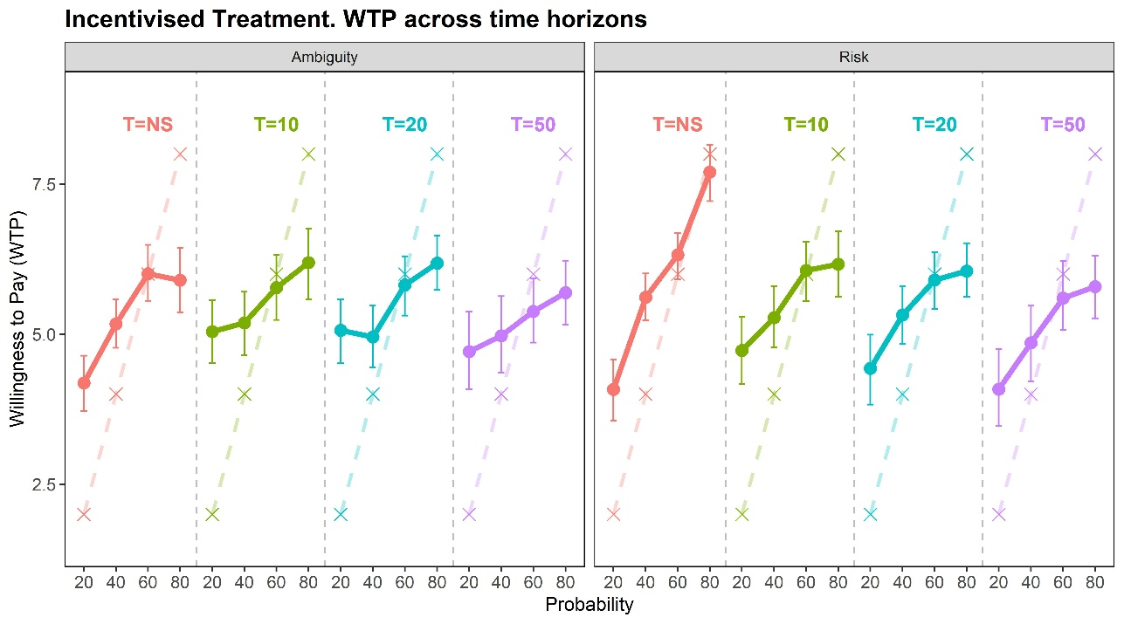
Figure 2, Dot plots with average values and error bars (95% confidence intervals) across time horizons, RN-AN predictions are reported as “x” points connected by dashed lines,

We almost always observe an increase in the willingness-to-pay (WTP) as the probability increases (20%, 40%, 60%, 80%) for each treatment, where the same probability is presented over T different periods as shown in Table 1 and Figure 2, Starting with the case where large probabilities are presented to the participants (T=NS), in the case of ambiguity, we notice an increase in the average WTP as the underlying probability rises; however, this trend is less evident when moving from 60% to 80% under ambiguity, where the information about the underlying probability is not obvious, In the case of risk, the average values increase monotonically for T=NS (from 4.08 to 7.70), For T=10, 20, and 50, the average WTP under both ambiguity and risk conditions also increases monotonically, except for T=10 and P=80%, Focusing on the risk condition, we can observe that the range of variation is reduced, despite the underlying probabilities being the same, Specifically, while for T=NS we observe a variation from 4.08 to 7.70 euros, for T=50 the variation ranges from 4.08 to 5.90 euros, This preliminary evidence will be revisited in the inferential analysis,
When probabilities are small, subjects do not ignore them; however, they tend to insure themselves systematically less compared to when the probability is presented cumulatively, Keeping T constant, we observe that subjects are more likely to insure themselves as p increases, This is interesting because it could be seen as an attempt to separate the underestimation of low probabilities from narrow-bracketing, In risky conditions, subjects should assess and analyze the underlying probability in each problem. If this were true, we would also need to assume the existence of only System 2, that is the deliberative, analytical and conscious thinking process, then the absence of heuristics, and the management of such contexts as "Risk-as-analysis" and never as "Risk-as-sentiment". However, we know this is not always the case (Slovic et al., 2013; Caferra et al., 2024).
As a result, assuming that individuals rely on mental shortcuts and therefore consider what happens "in each T" rather than what happens "over the entire time horizon," we observe that, given the same T, a significant change in p is not ignored by subjects, but it is not valued as much as the same changes expressed in terms of cumulative probabilities. Subjects do consider even small probability changes when T is constant, not ignoring them, which makes their behavior more consistent with narrow-bracketing than with ignoring changes in low probabilities.

Figure 3 illustrates the variations across P for each T of table 1. That is, we keep constant the cumulative P and vary frequency of trials T, then the low p following the survival probability formula. That is, for the same time period, the effect of an increase in the underlying probability and, thus, the occurrence of the adverse event.

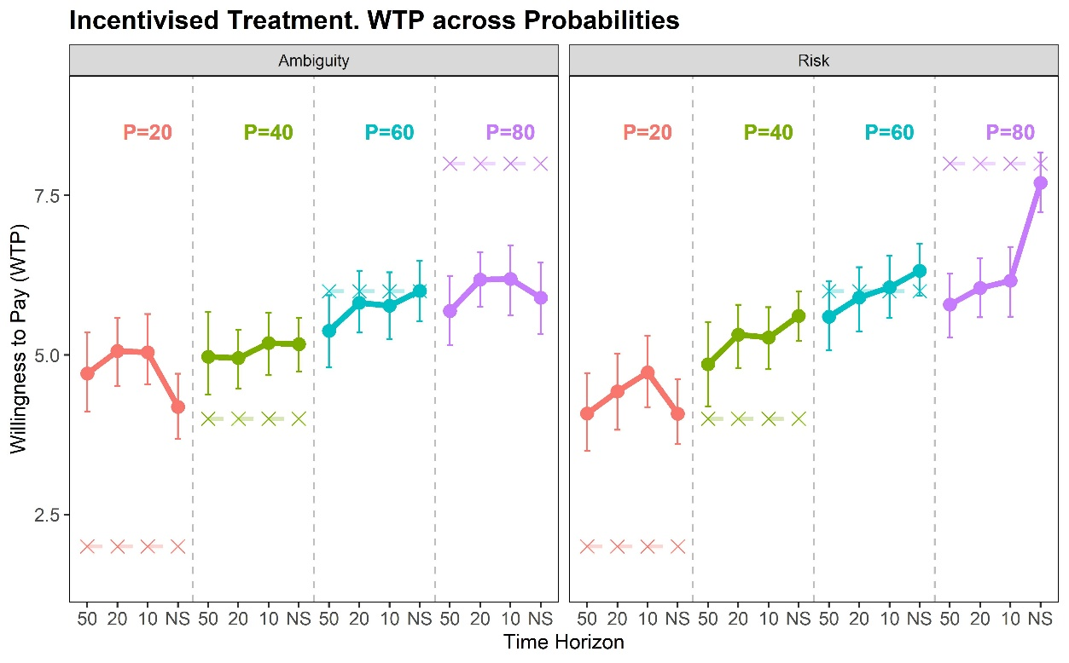
Figure 3 Dot plots with average values and error bars (95% confidence intervals) across P, RN-AN predictions are reported as “x” points connected by dashed lines.

Figure 3 displays an additional interesting result: when the large underlying probability is not that large (P=20%; red lines in the graphs), reporting the overall probability (T=NS) to the subjects is less effective in improving their WTP for the insurance compared to the case where the same adverse event is described to the subjects by reporting smaller period-by-period probabilities, emphasizing the frequency of the events (T=10, T=20, T=50). In other words, the effect of the frequency of the draws is more salient than the effect related to the size of the probabilities, if the overall probability is not very high and the risky communication is not clear (that is under ambiguity). On the contrary, for large underlying probabilities and a clear communication of the risk, the effect related to the size of the reported probabilities (T=NS) is higher than the effect related to the frequency of drawn reporting period-by-period lower probabilities. This is evident by observing the violet line (P=80) under risk.
Overall, the results show that under risk conditions, increasing the underlying probability leads to a higher average WTP, with subjects being more sensitive to changes in the overall probability than to changes in low probabilities. Under ambiguity conditions, the results are less clear, with a smaller range of variation in WTP and no increase from P=60% to P=80%. When using a framing with smaller probabilities over multiple periods, the range of variation in WTP is reduced, despite the same increase in probability as in T=1. This effect is more pronounced under risk conditions, while it is weaker under ambiguity.
Generally speaking, considering the Risk-Neutral Ambiguity-Neutral (RN-AN) prediction, we observe that subjects exhibit greater risk aversion at low probability levels, while they become more willing to take risks as the portion of the endowment "sacrificed" for insurance increases. Specifically, when the underlying probability is 20%, subjects, on average, insure more than 20% of their endowment—roughly double that amount.
This effect diminishes as the underlying probability approaches 60%, at which point the willingness to pay (WTP) aligns with the behaviour of a risk-neutral individual.
Beyond this threshold, subjects are more willing to take higher risks. In fact, the average level of insurance decreases compared to the expected prediction when the probability is 80%, This effect is independent of the framing of the decisions.
Therefore, we can conclude that the increase in the WTP is less than proportional to the increase of risk, keeping constant the potential loss (that is, the entire income). Therefore, there emerges a trade-off between demanding insurance, risk levels and the net disposable income after the insurance payment.
This change can be decomposed into two effects: on one hand, individuals tend to insure more in absolute terms as the risk associated with the adverse event increases. On the other hand, there is a need to balance the potential losses from the adverse event with the potential gains in case it does not occur. As a result, individuals feel the necessity to retain some of their income rather than invest it entirely in insurance. The evidence suggests that the endowment-insurance substitution effect is stronger when the probability of the adverse event is low, allowing individuals to maintain a significant proportion of their net income, even after the insurance premium is paid. However, this effect diminishes as risk increases, as the income effect becomes more dominant and the need to preserve available income for potential gains increases. In summary, relative to the insurance paid, loss aversion is greater when disposable income (and thus potential gains) remains high, while it approaches to risk-neutrality as the probability of the adverse event rises, then higher reservation prices for the insurance will also mean low net disposable income. Therefore, the opportunity cost of converting income in insurance increases, reducing the size of the increase of the willingness-to-pay for the insurance.
Moving on to a more sophisticated inferential analysis, we present a panel data regression model with random effects, aiming to test the statistical significance of the observations made so far,
Building on the descriptive insights, we use the following basic model:
$$y_{i,d}=α+β_{1}Gender_{i}+β_{2}Order_{id}+β_{3}Probability_{id}+u_{i}+ε_{id}$$
Where $y_{i,t}$ is the dependent variable, that is the Willingness-to-pay (WTP), for individual i for the d-th decision problem faced, while $Gender_{i}$ is the independent variable indicating gender (1 for female, 0 for male) for individual i (51% of female in our sample) as a control for risk aversion and demographic characteristics. The $Order_{id}$is the independent variable representing the order in which the problem is presented, while $Probability_{id}$is the independent variable representing the probability presented to individual i for the decision d. As standard for Panel models with random effects. $u_{i}$is the random individual effect, while $ε_{id}$is the idiosyncratic error term. In this context, d identifies the decision problems.

Each of the 32 decision problems is characterized by a combination of probability and Time horizon (as in table 1). We perform several subdivisions of the sample, considering the dynamics keeping constant the Time Horizon and then the frequency of drawn (T=NS; T=10; T=20; T=50) as in table 5; and the cumulative large probability (P=20%; P=40%; P=60%; P=80%), as in table 6.

 | Full |  | P=20% |  | P=40% |  | P=60% |  | P=80%
 | Amb | Risk | Amb | Risk | Amb | Risk | Amb | Risk | Amb | Risk
Female | 1.268*** | 1.668*** | 2.335*** | 2.330*** | 1.261*** | 1.568*** | 1.083*** | 1.369*** | 0.393 | 1.266***
 | (0.311) | (0.339) | (0.375) | (0.460) | (0.394) | (0.393) | (0.378) | (0.349) | (0.347) | (0.365)
Log(Seconds) | -0.125 | 0.020 | 0.126 | 0.128 | -0.063 | -0.032 | -0.052 | -0.314 | -0.082 | -0.126
 | (0.102) | (0.089) | (0.160) | (0.177) | (0.183) | (0.124) | (0.163) | (0.224) | (0.218) | (0.176)
Probability | 1.431*** | 3.315*** | -3.377** | -0.716 | 1.002 | 1.983** | 0.946 | 1.367** | 0.610 | 2.556***
 | (0.463) | (0.430) | (1.478) | (1.299) | (0.732) | (0.779) | (0.604) | (0.538) | (0.529) | (0.400)
Order | 0.076*** | 0.111*** | 0.047 | 0.050 | 0.049 | 0.059 | 0.028 | 0.047 | 0.098*** | 0.022
 | (0.022) | (0.020) | (0.037) | (0.036) | (0.038) | (0.038) | (0.035) | (0.033) | (0.036) | (0.043)
Constant | 4.607*** | 3.668*** | 3.429*** | 2.892*** | 4.398*** | 4.175*** | 5.135*** | 5.673*** | 5.349*** | 5.458***
 | (0.453) | (0.388) | (0.632) | (0.580) | (0.669) | (0.547) | (0.645) | (0.674) | (0.756) | (0.636)
Observations | 1,280 | 1,280 | 320 | 320 | 320 | 320 | 320 | 320 | 320 | 320
Log Likelihood | -2.772.948 | -2,721.334 | -696.029 | -671.076 | -693.081 | -671.205 | -695.775 | -680.247 | -714.188 | -689.749
Table 5. Regression models with random effects and robust standard errors. Response variable: WTP. ***, **, * are for p-values of 0.1, 0.05, 0.01,
It is interesting to note the gender effect, which is more noticeable under risk conditions. In risk conditions, the gender effect is always statistically significant. Under ambiguity, the statistical significance of the gender effect vanishes under high probability.
Considering the effect of probability, there is a positive impact from increasing the probability, more evident in a risky context. Under ambiguity, when observing the results in the column HP=20%, we notice that framing with period-by-period probabilities across different subperiods leads to greater salience of the WTP, and thus a higher insurance WTP, as noticed in the description of the dynamics in Figure 3.
In Table 6, we report the results of splitting the sample across different time horizons, To compare the probability effect, in this case, the probabilities are normalized by considering the overall underlying probability. That is, even in cases where the time horizon is 10, 20, or 50, so in cases where subjects are presented with the small p, in the analysis we consider the underlying cumulative P as a regressor, in order to bring the variable to the same scale and be able to compare the magnitude of the coefficients.

 | Time Horizon Not Specified |  | Time Horizon=10 |  | Time Horizon=20 |  | Time Horizon=50
 | Amb | Risk | Amb | Risk | Amb | Risk | Amb | Risk
Female | 0.691** | 1.150*** | 1.190*** | 1.770*** | 1.406*** | 1.850*** | 1.778*** | 1.924***
 | (0.315) | (0.328) | (0.419) | (0.383) | (0.419) | (0.363) | (0.419) | (0.493)
Log(Seconds) | 0.175 | 0.206 | 0.119 | -0.040 | -0.056 | 0.051 | 0.190 | 0.142
 | (0.176) | (0.201) | (0.180) | (0.170) | (0.180) | (0.153) | (0.180) | (0.184)
(Norm) Probability | 3.011*** | 5.862*** | 1.954*** | 2.565*** | 2.046*** | 2.581*** | 1.641*** | 2.895***
 | (0.600) | (0.567) | (0.484) | (0.516) | (0.484) | (0.504) | (0.484) | (0.495)
Order | 0.255** | 0.237** | 0.082** | 0.034 | 0.066** | 0.109*** | 0.046 | 0.042
 | (0.121) | (0.100) | (0.033) | (0.035) | (0.033) | (0.034) | (0.033) | (0.033)
Constant | 2.302*** | 1.423* | 3.265*** | 3.466*** | 3.661*** | 2.582*** | 2.890*** | 2.275***
 | (0.849) | (0.732) | (0.678) | (0.596) | (0.678) | (0.584) | (0.678) | (0.651)
Observations | 320 | 320 | 320 | 320 | 320 | 320 | 320 | 320
Log Likelihood | -696.331 | -659.233 | -691.786 | -686.835 | -673.622 | -673.772 | -718.885 | -699.871
Table 6. Regression models with random effects and robust standard errors. Response variable: WTP. ***, **, * are for p-values of 0.1, 0.05, 0.01.
Considering the probability effect, we can confirm the evidence discussed above. When the overall probabilities (T=NS) are provided, the sensitivity of WTP is greater compared to the case where, for the same overall underlying probability, smaller intra-period probabilities are provided. This is evident from the magnitude of the coefficients for the Probability variable. For instance, under risk, the coefficient is 5.862 for T=NS, and it is halved for T=10 (2.565). The magnitude of the effect is less evident under ambiguity (see also the coefficient plots that will be discussed later - see figures 6).
The results are more evident under risk conditions. The behaviour pattern is similar when transitioning to ambiguity conditions, although the effects found under risk conditions are weaker in ambiguity conditions, with the probability effect not being statistically significant.
In light of the results obtained, we can conclude that framing matters. The effect it produces does not always follow the intuitive expectation that presenting the overall high probability is always better than presenting smaller intra-period probabilities. In fact, we could say that, on average, subjects do not tend to ignore the adverse event in scenarios with low probabilities spread over multiple periods.
Specifically, when the overall probability is 20% or 40%, subjects are generally risk-averse, regardless of the framing. It is interesting to note that, even when the overall probability is low and not clearly communicated (as in the case of ambiguity), presenting a scenario that emphasizes the frequency of occurrences over the size of the probability—that is, presenting cases with smaller intra-period probabilities over multiple sub-periods—leads subjects to focus more on the probability of the event, resulting in a higher willingness to insure. This is reflected in the statistically significant negative effect (Figure 4) of increasing the probability size (and consequently reducing the time span) for P=20% under ambiguity conditions.
If risk communication is unclear, those conveying low and moderate risks who lack a clear understanding of the impact and wish to encourage subjects to protect themselves more against such risks can consider a different framing, presenting the probability range for each period.
Considering cases where the underlying probability is high (P=60%; P=80%) and the characteristics of the adverse event are clearly presented, as in risk conditions, presenting high probabilities leads subjects to perceive the risk as more salient and to insure more. Regardless of the context, for medium-to-high probabilities (60%), subjects tend to be risk-neutral, independent of framing and the clarity of the information presented, while they become risk-seeking for high probabilities. As mentioned earlier, this dynamic depends on how subjects replace the opportunity to preserve income with investing it in insurance. In this case, the effect related to the increase in risk is less than proportional in relative terms to the increase in WTP, as giving up additional disposable income becomes a higher cost for subjects, In case of high probabilities (P=80%), clearly reporting the overall high probability is leading subjects from risk-loving to risk-neutrality, then to a more protective behaviour compared to other cases.

Therefore, we note that greater informational clarity—removing ambiguity in the communication of the adverse event under objective risk conditions—and proper framing are crucial for an appropriate risk mitigation strategy by individuals.
It thus becomes extremely interesting to observe whether this behaviour also depends on the salience of the economic consequences resulting from individuals' choices.

3.2. Unincentivised Treatments
For the non-incentivised treatments, we report the same analysis as in the previous section, To facilitate the presentation, we provide the graphs that summarize the results in the text and the reference tables in the appendix.
We provide graphical evidence by comparing the previous Figures 2 and 3, now including the non-incentivised case (Figure 4 and 5). Average values can be also found in the appendix table A1. As with the incentivised treatments, we observe an increase in the average WTP as the overall underlying probability increases, but the sensitivity of WTP appears to be weaker.
We notice significant differences in the ranges of variation, especially in the case of risk. There is much more heterogeneity in behaviour and greater sensitivity in the WTP when real economic incentives are present.
Comparing the subjects' WTP with the corresponding RN-AN prediction, we can observe that, in this case as well, subjects tend to be more risk-averse for low probabilities (Figure 4, P=20%), while they tend to be more risk-loving for high probabilities (Figure 4, P=80%).

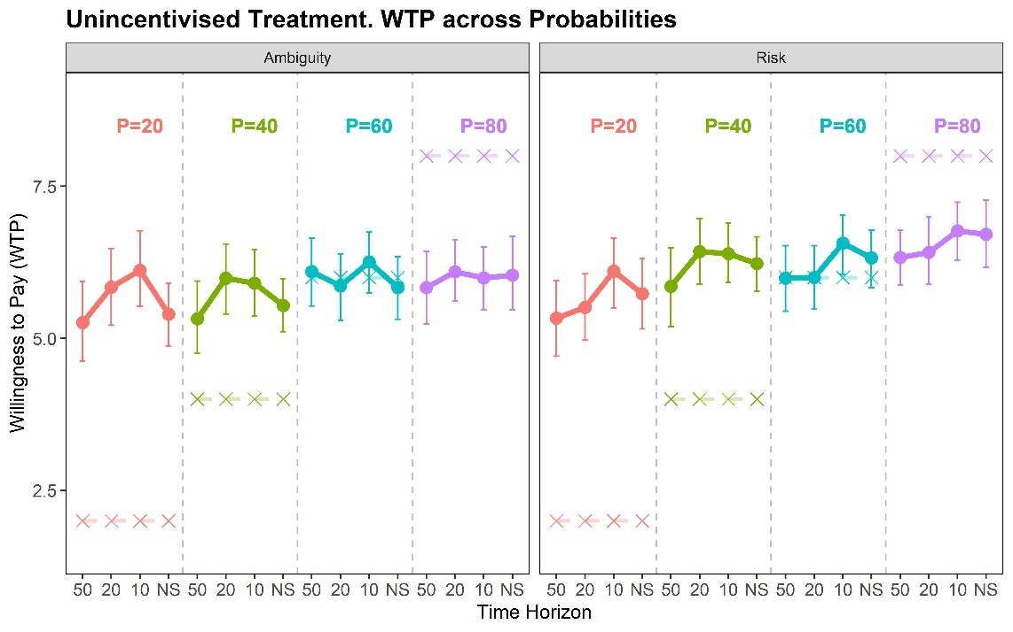
Figure 4 Dot plots with average values and error bars (95% confidence intervals) for comparison. RN-AN predictions are reported as “x” points connected by dashed lines.
This pattern is also evident when the average WTP values are aggregated, taking into account the time horizon. Even in these cases, the comparison with the Risk-neutral Ambiguity-Neutral prediction leads to the same result: subjects are more risk-averse for low probabilities, risk-neutral for medium-high probabilities, and risk-seeking for high probabilities. However, in the latter case, under risk conditions, the reported WTP levels are lower compared to those under incentive conditions, where the subjects approach risk-neutrality for P=80% and T=NS.
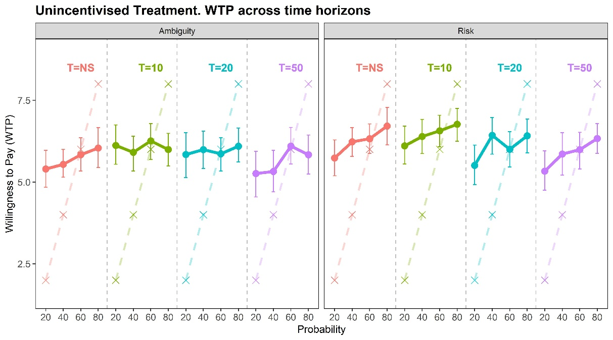
Figure 5. Dot plots with average values and error bars (95% confidence intervals) for comparison. Theoretical predictions are reported as “x” points connected by dashed lines.
These results are confirmed by the regressions, conducted using the same models proposed earlier. To compare the magnitude of the effects with the incentivised results, here we report the coefficient plots (estimates can be found in the table A2- across large P and table A3- across different T in the Appendix, following the same structure of tables of 5 and 6 of the incentivizes section 3.1). It is clear that many of the results lose statistical significance. This is also evident from the coefficient plots (figures 6 and 7).
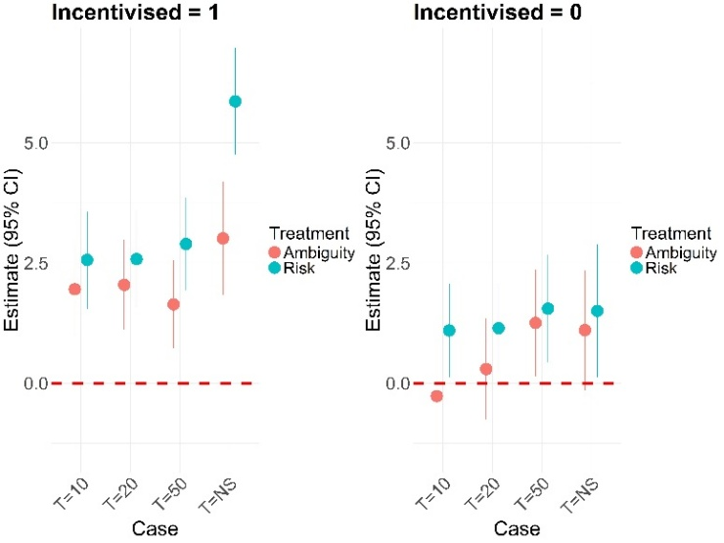
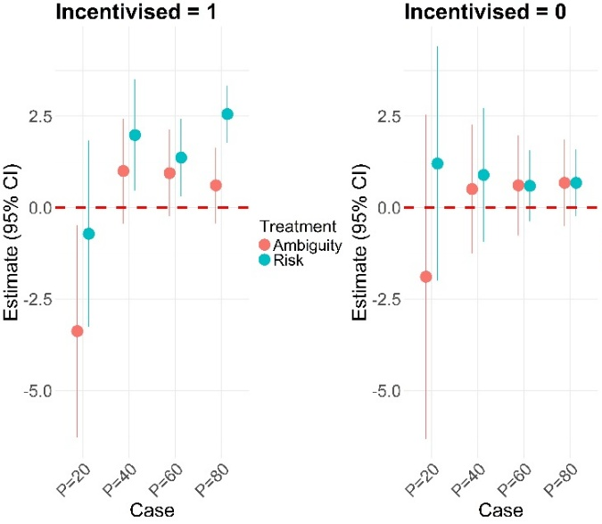
Figure 6. Probability Size Effect. Coefficient plots.

We can therefore conclude that, although the sign of the coefficients is the same in both incentivised and non-incentivised cases, when economic consequences are real, the magnitude of the effects is greater, making the results statistically valid and robust.
That is, the framing effect is crucial when the economic consequences are real. Additionally, without incentives, the lack of clarity of the information provided (in the transition from risk to ambiguity) does not significantly change the subjects' choices.
Why is this the case? Following recent experimental studies (Caferra et al., 2024), economic incentives can lead to different ways of making decisions under conditions of risk and ambiguity.
Following the study, a key factor why subjects' behaviours may show marked differences is the time taken to make the choice. Although important decisions require time and careful thought, everyday decisions often occur automatically, guided by intuitive thinking and behavioural biases. In this context, dual-process models distinguish between System One, which involves fast, intuitive decisions, and System Two, which involves slow, deliberate choices (Epstein, 1994; Kahneman, 2003, 2011). Complex tasks highlight this difference, especially in time-consuming tasks where decision-making behaviour varies (Moffatt, 2005). In this context, fast decisions (System One) are related to “risk as feeling” where intuition drives choices, while slow decisions (System Two) involve “risk as analysis” (Loewenstein, 2001). This pattern manifests in real-world contexts, such as financial markets, where quick decisions can lead to missed opportunities or avoid risky losses (Kirchler et al., 2017). From our data, we observe that the introduction of economic incentives and real economic consequences leads participants to engage System Two, making more reflective decisions. In contrast, the absence of real consequences encourages participants to make more intuitive and impulsive choices, typical of System One. As displayed in figure 8, the time spent under incentives is systematically high.
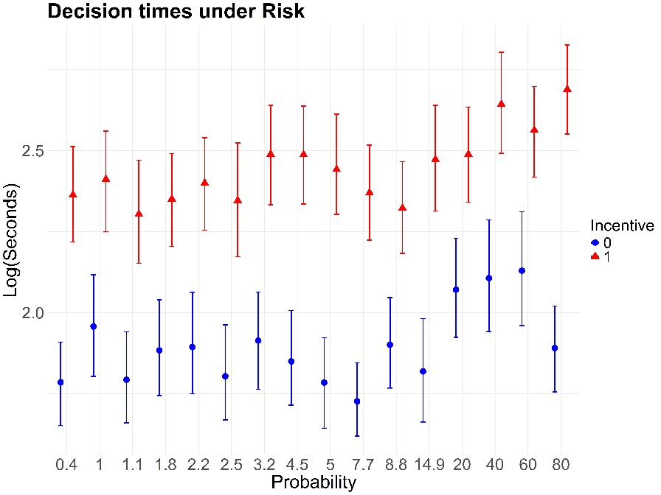

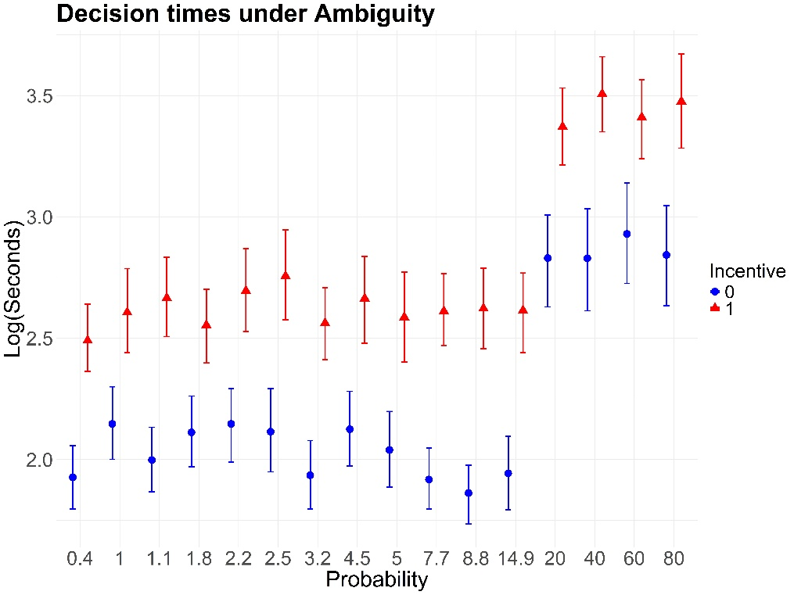

Figure 8. Time spent in each decision. Time is expressed as the logarithm of the seconds spent in each decision considering the screen where the event is presented and the WTP is declared.

Consequently, we can confirm the systematic evidence that, in the absence of incentives, subjects tend to rely on heuristics and are guided by their perceptions of risk, without investing time in reflective calculations. As a result, we could conclude that the lack of incentives leads subjects to treat risk as "Risk-as-sentiment". In contrast, the presence of economic incentives and real economic consequences encourages subjects to invest more time, thus becoming more reflective in their risky choices, attempting to assess the underlying risk. From a WTP perspective, as extensively discussed earlier, this leads to a greater salience of the framing of the received information, making preferences regarding certain communication strategies more distinct compared to others. The additional timing dimension analyzed shows how differences are not only evident in the outcome but also in the decision-making processes leading to that outcome. The presence of incentives leads to treating the risky context as "Risk-as-analysis" (Slovic et al., 2013). This highlights that the way individuals process risk and make decisions varies depending on the incentives, shaping both their approach and the resulting choices.

3.3. Summary and Discussion
The analysis conducted was designed to examine the framing effect, where, given the same underlying risk, decisions are made under probable low probabilities versus cumulative probabilities. When the probabilities are small, subjects may underinsure for various reasons: people may exhibit narrow-bracketing, considering only the probability in the specific subperiod of T and not the cumulative probability over T (i.e. P), or they may simply tend to ignore low probabilities. These two concepts are not independent, as we can have individuals who both narrow brackets and ignore low probabilities. We can summarize the main results as follows:
- People do not ignore small probable probabilities, as the average insurance reservation price is never close to zero, which would be the case if people ignored risk and preferred to take all the money as potential gains. This is evident in Table 4, and further supported by Figures 2 and 3.
- People are less sensitive to changes in small probable probabilities than to changes in the underlying cumulative probability, even when the probability is the same. This is strongly related to the framing effect, As mentioned earlier, stating that the overall probability increases from 20% to 40% is equivalent to saying that it increases from 2.2% to 5% when considering the intra-period probability (p over T=10 subperiods). This result is confirmed in the inferential analysis and can be easily summarized by observing the upper plot of Figure 6: in the incentivized case, when T=NS, if the decision problem displays the cumulative high probability, the magnitude of the coefficient is significantly higher compared to other cases where providing the same cumulative probability in terms of probable small probabilities results in halving the magnitude of the effect.
- Reporting cumulative probabilities is not always the best strategy. Under ambiguity, for small cumulative probabilities, the framing effect of p over T (i.e., reporting probable small probabilities) is more effective in raising insurance demand. This is evident in the left panel of Figure 3, where, for P=20% (the orange line), willingness to pay is higher for T=10 and T=20 compared to the case where the cumulative probability is provided (T=NS). This result is confirmed in the coefficient plot (Figure 6), where. in the graph at the bottom, the incentivized ambiguity case shows that an increase in the displayed probability (i.e., given P, an increase of p and then a reduction of T) leads to a statistically significant reduction in willingness to pay.
- The clarity of risk communication is crucial for high cumulative probabilities. This is strongly evident when comparing the dynamics under risk and ambiguity for P=80%, as shown in both Figures 2 and 3 and in the upper plot of Figure 6 under incentive, For T=NS, the coefficient and subjects' sensitivity to probability changes is significantly higher under risk.
- Considering subjects' risk aversion, we observe an interesting relationship between risk aversion, willingness to pay, and the net income effect, as seen in Figures 2 and 3. When the risk is low, and consequently the expected value is also low, subjects tend to be risk-averse because it is less costly to be so, given that a large portion of their net income remains available for potential gains. However, when the risk is high and the expected value increases accordingly, two different effects occur: a substitution effect, where individuals substitute (and invest) their available income with insurance, because it is relatively more costly to maintain uninsured income (since the probability of losing it is high), and an income effect, where individuals want to retain the possibility of maintaining gains and not invest everything in insurance, as nothing would be left in case of a win. The overall effect leads to a reduction in risk aversion.
- Comparing incentivized versus unincentivized cases, we obtain different results in terms of dynamics, accuracy, and the reflectiveness of subjects' responses. The dynamics are similar, as subjects shift from risk aversion to risk neutrality even without economic consequences and increase their willingness to pay as the probability rises. However, the sensitivity of subjects to probability changes is less pronounced, and the erratic component is much higher. In regressions, the point estimate follows the same direction but with a higher magnitude, and the confidence intervals often lead to statistically insignificant results. Regarding response times, subjects are systematically less reflective in their choices.

- Conclusions
This experiment aims to explore the role of framing adverse events and the clarity with which such events are presented to subjects. Interestingly, we also observe the significance of economic incentives in the decision-making process, which influences the subjects' insurance choices.
Regarding decision framing, we examine, for the same overall probability of an event, the trade-off between the size of the reported probability and the frequency with which an event may occur. Specifically, we exploit the properties of survival probability, where the probability of an event not occurring in a specific period is 1-p, and the probability of it not occurring over multiple periods T is the joint probability that it does not occur in each of the T periods, that is, (1-p)^{T}, From this, we can derive the probability 1−P=(1−p)^{T} that the event will not occur overall. By considering different levels of P, representing various underlying probabilities for the adverse event and different periods T, we calculate the corresponding p<P such that, for the same P, the same event is presented to subjects. This implies that the event may occur in any of the T periods with probability p, causing them to lose all their wealth unless they are insured. By extending T and reducing the magnitude of the probability period by period, we emphasize the frequency with which an event may occur. In contrast, by shortening the time frame and increasing the reported probability, we place greater weight on the size of the probability of occurrence.
Another aspect of communicating the adverse event concerns not only the framing strategy but also the clarity of the presentation, From a microeconomic and experimental perspective, we distinguish between cases where probabilities are clearly stated and do not need to be estimated (risky conditions) and cases where the information provided is vague, the probabilities are uncertain, and must be estimated (ambiguous conditions). Concerning the salience of economic consequences, we consider scenarios in which experiments are economically incentivized, and those in which the losses are hypothetical, making the economic consequences negligible.
One conclusion is clear: incentives matter in various ways. There is also a strong framing effect, as subjects do not perceive a high probability as equivalent to the same small probability presented in a different way.
We systematically present the main conclusions of the study. First, in incentivised sessions, it is observed that the framing effect is asymmetric and influenced by the level of informational clarity. Specifically, for low overall probabilities and in cases of informational ambiguity, the effect related to the frequency of draws increases the level of wealth invested in insurance. Conversely, when the probability is high and clearly presented, the size effect leads individuals to invest more in insurance.
Framing becomes less effective when there are no incentives. When economic consequences are negligible, individuals' judgments are less sensitive to how information is presented.
In addition to differences in outcomes, it is interesting to note how the decision-making process varies. In the absence of incentives, more impulsive choices are observed, whereas in the presence of incentives, individuals tend to reason in a more reflective manner.
Another interesting conclusion, with broader implications, is independent of both framing and the size of economic incentives. When comparing levels of risk aversion and risk propensity, it is essential to examine the relationship between total income, insurance investment, and net income. For low probabilities of adverse events and significant losses, individuals exhibit risk aversion. In this case, considering the income they must forgo to obtain prudent insurance coverage, risk aversion is relatively inexpensive, as the net income available after purchasing insurance remains high. As the probability of adverse events increases, two contrasting effects occur: on one hand, investment in insurance rises, but on the other hand, the opportunity cost of further investment grows, as it significantly reduces available income. This income effect—that is, the need to maintain a net income—can lead to different, more or less desirable outcomes from a social perspective. On one hand, there is a need to preserve wealth. An overly conservative attitude, with high levels of risk aversion, could lead to lower income levels, even though they may be more consistently maintained over time. On the other hand, a high risk propensity could lead to greater economic losses, driven by the desire to achieve higher income. In this context, framing and the clarity of risk communication can help guide individuals toward making more accurate choices. Our results confirm this aspect. It is noteworthy that appropriate framing and clear presentation of risky information—especially when economic consequences are real—can help individuals approach levels of risk neutrality.
In light of all these findings, the study highlights several implications and avenues for future research, It clearly shows the indispensability of economic incentives for studying treatment effects in economic decision-making contexts. Moreover, it demonstrates that the behaviour of individuals can be studied not only by evaluating the economic outcomes of their choices but also by examining the temporal dimension of their decision-making processes. Under incentives, subjects are sensitive to the way information is provided, and although the information itself remains the same, the subjective perception changes depending on how the same aspects are framed. As a final takeaway, we can conclude that the proper combination of framing and incentives can guide subjects to avoid undesirable economic losses.

References

Barberis, N. (2013). The psychology of tail events: progress and challenges. American Economic Review, 103(3), 611-616.
Burke, M. S., Carter, J. R., Gominiak, R. D., & Ohl, D. F. (1996). An experimental note on the allais paradox and monetary incentives. Empirical Economics, 21(4), 617–632.
Caferra, R., Hey, J. D., Morone, A., & Santorsola, M. (2023). Dynamic inconsistency under ambiguity: An experiment. Journal of Risk and Uncertainty, 67(3), 215-238.
Caferra, R., Hey, J., & Morone, A. (2024). Fast and slow dynamic decision making under ambiguity. Journal of Risk and Uncertainty, 1-16.
Chaudhry, S. J., Hand, M., & Kunreuther, H. (2020). Broad bracketing for low probability events. Journal of Risk and Uncertainty, 61(3), 211-244.
Cleeton, D. L., & Zellner, B. B. (1993). Income, risk aversion, and the demand for insurance. Southern economic journal, 146-156.
Clot, S., Grolleau, G., & Ibanez, L. (2018). Shall we pay all? An experimental test of random incentivized systems. Journal of behavioral and experimental economics, 73, 93-98.
Corcos, A., Montmarquette, C., & Pannequin, F. (2020). How the demand for insurance became behavioral. Journal of Economic Behavior & Organization, 180, 590-595.
Epstein, S. (1994). Integration of the cognitive and the psychodynamic unconscious. American Psychologist, 49(8), 709–724.
Etchart-Vincent, N. (2004). Is probability weighting sensitive to the magnitude of consequences? An experimental investigation on losses. Journal of Risk and uncertainty, 28(3), 217-235.
Feng, J., Xu, X., & Zou, H. (2023). Risk communication clarity and insurance demand: The case of the COVID-19 pandemic. Journal of Economic Dynamics and Control, 146, 104562.
Ghirardato, P. (2004). Defining ambiguity and ambiguity attitude. In Uncertainty in Economic Theory (pp. 36-45). Routledge.
Henrich, L., McClure, J., & Crozier, M. (2015). Effects of risk framing on earthquake risk perception: Life-time frequencies enhance recognition of the risk. International journal of disaster risk reduction, 13, 145-150.
Hertwig, R., Barron, G., Weber, E. U., & Erev, I. (2004). Decisions from experience and the effect of rare events in risky choice. Psychological science, 15(8), 534-539.
Jaspersen, J.G. (2016) Hypothetical surveys and experimental studies of insurance demand: a review. Journal of Risk and Insurance 83(1): 217–255.
Kahneman, D. (2003). A perspective on judgment and choice: Mapping bounded rationality. American Psychologist, 58(9), 697–720.
Kahneman, D. (2011). Thinking, fast and slow. Farrar, Straus and Giroux.
Kahneman, D., & Lovallo, D. (1993). Timid choices and bold forecasts: A cognitive perspective on risk taking. Management science, 39(1), 17-31.
Kahneman, D., & Tversky, A. (2013). Prospect theory: An analysis of decision under risk. In Handbook of the fundamentals of financial decision making: Part I (pp. 99-127).
Kirchler, M., Andersson, D., Bonn, C., Johannesson, M., Sørensen, E. Ø., Stefan, M., & Västfjäll, D. (2017). The effect of fast and slow decisions on risk taking. Journal of Risk and Uncertainty, 54(1), 37–59.
Kunreuther, H. (1996). Mitigating disaster losses through insurance. Journal of risk and Uncertainty, 12, 171-187.
Kunreuther, H., & Pauly, M. V. (2010). 10. insuring against catastrophes. The Known, the Unknown, and the Unknowable in Financial Risk Management: Measurement and Theory Advancing Practice, 210.
Laury, S. K., McInnes, M. M., & Swarthout, J. T. (2009). Insurance decisions for low-probability losses. Journal of Risk and Uncertainty, 39, 17-44.
Le Roux, S. (2020). Climate change catastrophes and insuring decisions: A study in the presence of ambiguity. Journal of Economic Behavior & Organization, 180, 992-1002.
Loewenstein, G. F., Weber, E. U., Hsee, C. K., & Welch, N. (2001). Risk as feelings. Psychological Bulletin, 127(2), 267–286.
Madsen, D. Ø., & Stenheim, T. (2015). Experimental methods in economics and psychology: A comparison. Procedia-Social and Behavioral Sciences, 187, 113-117.
Matousek, J., Havranek, T., & Irsova, Z. (2022). Individual discount rates: a meta-analysis of experimental evidence. Experimental Economics, 25(1), 318-358.
Moffatt, P. G. (2005). Stochastic choice and the allocation of cognitive effort. Experimental Economics, 8(4), 369–388.
Morone, A., & Caferra, R. (2024). The Ambiguity Box: A new tool to generate ambiguity in the lab. Journal of Behavioural and Experimental Economics, 113, 102299.
Morone, A., & Caferra, R. (2024). The Ambiguity Box: A new tool to generate ambiguity in the lab. Journal of Behavioural and Experimental Economics, 113(2024), 102299.
Plott, C.R. (1986), Rational Choice in Experimental Markets. The Journal of Business, 59(4, part 2), S301-327.
Robinson, P. J., & Botzen, W. W. (2018). The impact of regret and worry on the threshold level of concern for flood insurance demand: Evidence from Dutch homeowners. Judgment and Decision making, 13(3), 237-245.
Robinson, P. J., & Botzen, W. J. W. (2019). Economic experiments, hypothetical surveys and market data studies of insurance demand against low‐probability/high‐impact risks: A systematic review of designs, theoretical insights and determinants of demand. Journal of Economic Surveys, 33(5), 1493-1530.
Selva, J., Sandri, L., Taroni, M., Sulpizio, R., Tierz, P., & Costa, A. (2022). A simple two-state model interprets temporal modulations in eruptive activity and enhances multivolcano hazard quantification. Science Advances, 8(44), eabq4415.
Slovic, P., Finucane, M. L., Peters, E., & MacGregor, D. G. (2013). Risk as analysis and risk as feelings: Some thoughts about affect, reason, risk and rationality. In The feeling of risk (pp. 21-36). Routledge.
Smith, V.L. (1982), Microeconomic Systems as an Experimental Science. The American Economic Review, 72(5), 923-955.
Smith, V.L. (1991), Rational Choice: The Contrast between Economics and Psychology. Journal of Political Economy, 99(4), 877-897.
Svorenčík, A. & H. Maas (2016). The Making of Experimental Economics: Witness Seminar on the Emergence of a Field. Springer.
Thaler, R. H. (1994). Quasi rational economics. Russell Sage Foundation.
Tversky, A., & Kahneman, D. (Eds.). (2000). Choices, values, and frames (pp. 375-406). New York: Cambridge University Press.
Viscusi, W. K. (1997). Alarmist decisions with divergent risk information. The Economic Journal, 107(445), 1657-1670.
Viscusi, W. K., Magat, W. A., & Huber, J. (1991). Communication of ambiguous risk information. Theory and Decision, 31(2), 159-173.
Voslinsky, A., & Azar, O. H. (2021). Incentives in experimental economics. Journal of Behavioral and Experimental Economics, 93, 101706.

Appendix
Table A1 reports the average WTP across scenarios for the unincentivized treatments,
 | a)Risk, Uncentivised,
 |  | Time Horizon |  |  | RN-AN
Probability | T=NS | T=10 | T=20 | T=50 | Prediction
20% | 5.54 | 6 | 5.44 | 5.19 | 2
40% | 6.17 | 6.28 | 6.18 | 5.61 | 4
60% | 6.38 | 6.44 | 5.87 | 5.84 | 6
80% | 6.85 | 6.72 | 6.32 | 6.3 | 8

 | b)Ambiguity. Uncentivised.
 |  | Time Horizon |  |  | RN-AN
Probability | T=NS | T=10 | T=20 | T=50 | Prediction
20% | 5.35 | 6.05 | 5.88 | 5.21 | 2
40% | 5.47 | 5.89 | 5.96 | 5.23 | 4
60% | 5.76 | 6.17 | 5.78 | 5.96 | 6
80% | 6.01 | 6.06 | 6.15 | 5,83 | 8

Table A1. Average WTP across scenarios for the uncentivised treatments.

Table A2 reports the regressions resulting from the sample analyzed categorized across the underlying cumulative probability for the unicentivised treatments.
 | Full |  | P=20% |  | P=40% |  | P=60% |  | P=80%
 | Amb | Risk | Amb | Risk | Amb | Risk | Amb | Risk | Amb | Risk
Female | 0.480 | 0.290 | 0.664 | 0.361 | 0.375 | 0.520 | 0.567 | 0.114 | 0.361 | 0.158
 | (0.326) | (0.331) | (0.447) | (0.454) | (0.374) | (0.376) | (0.354) | (0.366) | (0.403) | (0.380)
Log(Seconds) | -0.097 | -0.070 | 0.066 | -0.250 | -0.152 | -0.065 | -0.412** | -0.271 | -0.191 | 0.040
 | (0.088) | (0.092) | (0.201) | (0.204) | (0.185) | (0.150) | (0.200) | (0.189) | (0.177) | (0.199)
Probability | 0.518 | 1.002** | -1.889 | 1.203 | 0.508 | 0.895 | 0.609 | 0.596 | 0.679 | 0.679
 | (0.523) | (0.405) | (2.259) | (1.636) | (0.898) | (0.935) | (0.700) | (0.497) | (0.608) | (0.464)
Order | 0.051** | 0.042* | -0.004 | 0.006 | 0.063 | 0.067 | 0.052 | 0.018 | 0.058 | 0.071*
 | (0.025) | (0.021) | (0.053) | (0.043) | (0.047) | (0.041) | (0.040) | (0.039) | (0.038) | (0.038)
Constant | 5.403*** | 5.739*** | 5.243*** | 5.817*** | 5.415*** | 5.558*** | 6.211*** | 6.470*** | 5.681*** | 5.823***
 | (0.361) | (0.305) | (0.662) | (0.631) | (0.567) | (0.472) | (0.669) | (0.525) | (0.621) | (0.553)
Observations | 1.280 | 1.280 | 320 | 320 | 320 | 320 | 320 | 320 | 320 | 320
Log Likelihood | -2,902.714 | -2,.831.109 | -768.626 | -739.131 | -734.535 | -725.561 | -718.996 | -707.940 | -740.799 | -718.290
Table A2. Regression models with random effects and robust standard errors. Response variable: WTP. ***,**,* are for p-values of 0.1,0.05,0.01.
Table A3 reports the regressions resulting from the sample analyzed categorized across the different time horizons for the unicentivised treatments.

 | Time Horizon=Not Specified |  | Time Horizon=10 |  | Time Horizon=20 |  | Time Horizon=50
 | Amb | Risk | Amb | Risk | Amb | Risk | Amb | Risk
Female | 0.637* | 0.662** | 0.254 | 0.254 | 0.465 | 0.039 | 0.527 | 0.191
 | (0.377) | (0.335) | (0.394) | (0.347) | (0.394) | (0.430) | (0.394) | (0.444)
Log(Seconds) | -0.012 | -0.062 | -0.61*** | -0.319 | -0.094 | -0.206 | -0.077 | -0.237
 | (0.145) | (0.176) | (0.199) | (0.195) | (0.199) | (0.228) | (0.199) | (0.211)
(Norm) Probability | 1.104* | 1.504** | -0.267 | 1.098** | 0.297 | 1.144** | 1.254** | 1.552***
 | (0.637) | (0.707) | (0.594) | (0.499) | (0.594) | (0.469) | (0.594) | (0.569)
Order | -0.022 | -0.024 | -0.015 | 0.042 | 0.055 | 0.038 | 0.046 | -0.036
 | (0.127) | (0.114) | (0.041) | (0.034) | (0.041) | (0.038) | (0.041) | (0.040)
Constant | 4.860*** | 5.289*** | 7.382*** | 6.061*** | 5.344*** | 5.608*** | 4.542*** | 5.647***
 | (0.706) | (0.615) | (0.687) | (0.617) | (0.687) | (0.621) | (0.687) | (0.632)
Observations | 320 | 320 | 320 | 320 | 320 | 320 | 320 | 320
Log Likelihood | -722.448 | -720.059 | -718.188 | -712.832 | -721.557 | -719.673 | -757.051 | -735.385
Table A3. Regression models with random effects and robust standard errors. Response variable: WTP. ***,**,* are for p-values of 0.1,0.05,0.01.

This is a verbatim quote; we have not changed it.

